EXP 3-Regression and Optimization (Multi Linear and Polynomial regression)
Anusri T-24BAD010
SCENARIO 1 – MULTILINEAR REGRESSION
OUTPUT:
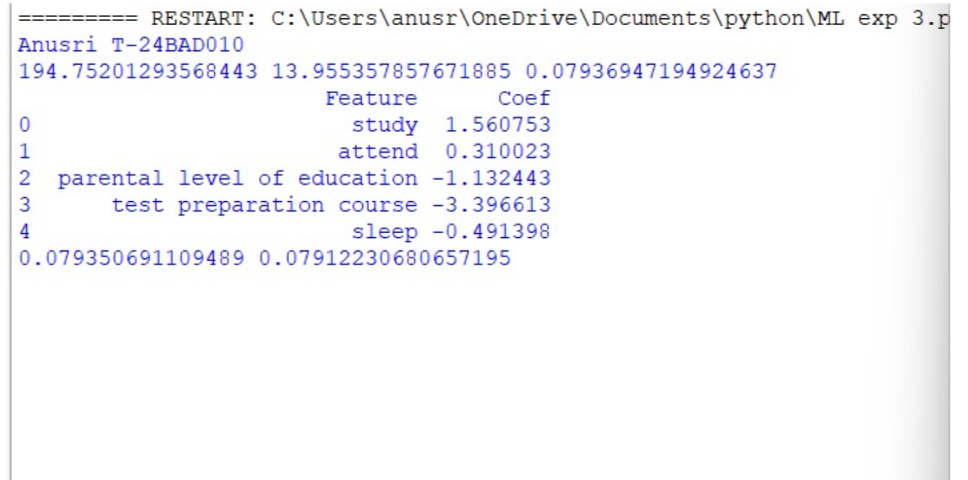
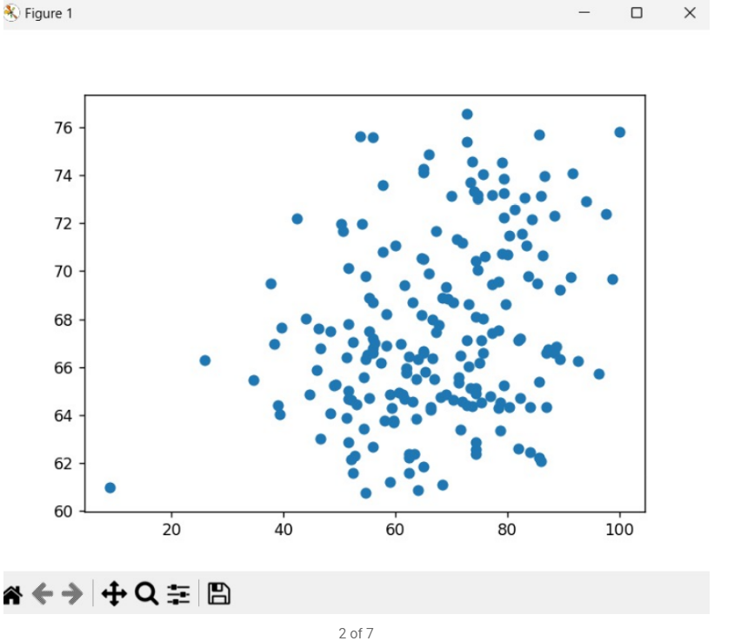
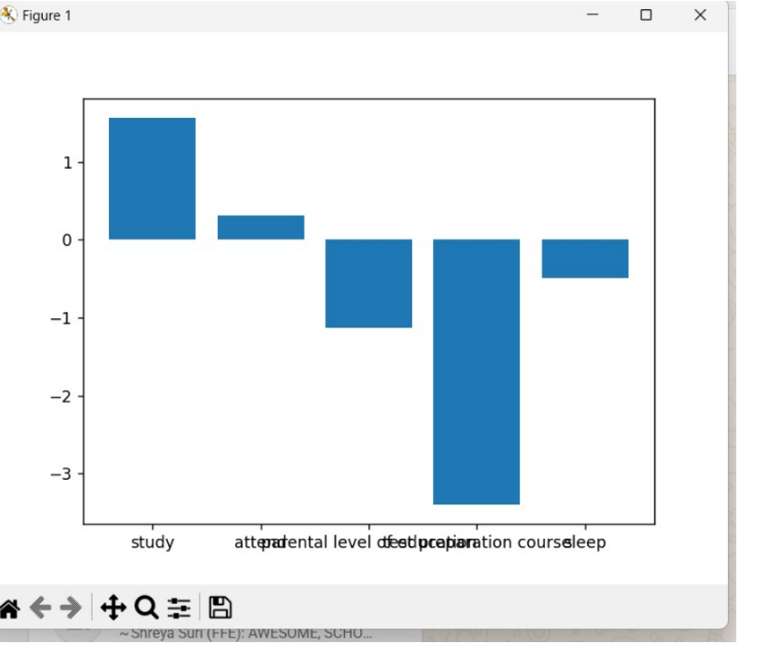
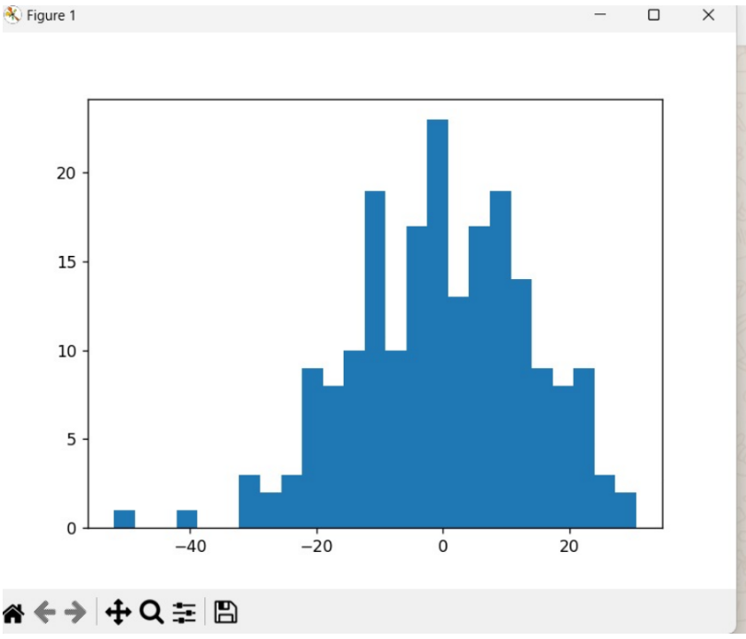

SCENARIO 2 – POLYNOMIAL REGRESSION
OUTPUT:
